AP Government
Lindblom Math and Science Academy

U.S. Government Syllabus

AP AMERICAN GOVERNMENT AND POLITICS

Instructor: Mr. Pond
Room: 325
Email: mpond@mrpond.org
Website: www.mrpond.org
Ning: www.apeagles.ning.com

COURSE DESCRIPTION:
We will explore the principles and practices of the American government system including the federal system, Congress, the President, the judiciary, the political and administrative process, including public policy. This is a college level course and is designed to provide you with the foundations of American Government and to help you succeed on the AP U.S. Government exam. The course will rely heavily on your input—including group discussions, projects, debates, data analysis and presentations.

GOALS
The primary goal of this course is to foster a passion for political citizenship. Studies continue to show sharp declines in political participation among young people. With a wide array of ongoing political debates including terrorism, the environment, abortion, immigration, among others, there are plenty of hot-button issues to consider. More than anything, I hope this course spurs you into action so that you make your voices heard and that you recognize you can facilitate change!

The second goal is to prepare you for successful completion of the AP U.S. Government and Politics exam. Therefore, you can expect discussion, exams and projects that reflect topics you may encounter when taking the exam.

OBJECTIVES
Upon completion of the course, students will master the following topics:
- The origins of the American Political Thought
- The origins of the American Constitution
- The framework for American Government
- The roles and functions of American Government
- The role(s) of the people, Media and PACs in American government
- Social and Political movements in American Government
- American Government in World view
- Critical examinations of primary and secondary sources including data charts, graphs and tables

GRADE COMPOSITION
- Quizzes -There will frequently be written quizzes or projects which will count for 20-50 points each. Quizzes are given at the beginning of class.
- Class participation - Students should come to class ready to participate fully in the topic of the day. A student’s class participation grade will be determined based on the following: Each day the student must bring all relevant class materials, contribute to the learning environment in a positive manner, be respectful of others, participate in the class discussion, complete classwork as assigned, and cooperate with partners in group work.
- Hot Topics – Weekly op-ed debates about current and ongoing political issues
- Homework - The completion of each homework assignment will be recorded by the teacher. Most assignments will be worth 10 points each unless specified by the teacher. Note-taking assignments will be worth 20 points each.
- Classwork -There will be regular in-class work and projects. Classwork is generally worth 10 points each unless otherwise instructed by the teacher.
- Tests (including group and individual projects given a test weight) generally count for 100-150 points. You will have a test at the end of each unit. Tests will be comprised of multiple choice questions, free response questions, document based questions and interpretive questions using charts, tables and images.
- Binder Checks - you are expected to bring your binder to class, on time, every time. Binders will be checked periodically to ensure that you are organized. All binders will be collected at the end of the year and will be checked for completeness.
- The Final Exams will count for 10% of your semester grade.

GRADING SCALE
90-100 % A
80-89 % B
70-79 % C
60-69 % D
59-0 % F

REQUIRED READINGS
- The American Democracy, Thomas E. Patterson, McGraw Hill, 8th Edition (2008) 557 p.
- Politico, which can be found at http://www.politico.com
- The Thirteen American Arguments, Howard Fineman, Random House: NY (2008) 320 p.
- American Government Packet, includes bound primary and secondary sources, as well as charts, graphs and diagrams. Including, but not limited to:
- Political theory from Locke, Rousseau and Montesquieu
- Federalist Papers #
- Jefferson, Notes on the State of Virginia
- Supreme Court dockets
- Interviews and editorials from modern politicians and political theorists

Additionally, any of several sources are STRONGLY recommended for a better understanding of American Government:

- Newspapers: the New York Times and Washington Post for U.S. political views and the Chicago Tribune and Sun Times for regional coverage

- A weekly news magazine like the NATIONAL JOURNAL or the CONGRESSIONAL QUARTERLY WEEKLY REPORTS. These are in the Library (and CQ is on the Internet). These are NOT the same as TIME or NEWSWEEK.

- There are a variety of news services and news summaries on the Internet. More information about the ‘net in class.

- The Daily Show and Colbert Report show a more humorous approach the American Government. They air at 10:00 p.m. and 10:30 p.m. on Comedy Central.

- Websites like www.politico.com, www.realclearpolitics.com provides daily political news updates, articles and videos. Other sites like www.drudgereport.com provide political and entertainment muckraking, while www.huffingtonpost.com provides liberal articles and news footage while www.michellemalkin.com provides conservative perspectives.

- Lastly, please be sure to visit the AP College Board website regularly for test prep and updates. Here’s a link to our class page: http://www.collegeboard.com/student/testing/ap/usgov/topics.html?usgovpol

I also HIGHLY recommend you pick up an AP study guide such as McDougal Littel’s Fast Track to a Five, Kaplan’s AP Government & Politics, or similar. These guides will help you review throughout the class and the practice tests are very useful prior to the AP exam. Copies of these guides will be available in the LMSA library.

MATERIALS
You will need the following for EVERY class unless noted by the instructor:
- Your textbook
- Your American Government Packet
- A 1.5”-2” 3-ring binder with folders
- Loose leaf lined paper
- A college or wide ruled notebook (recommended)
- Blue or black ink pens (NO Red!)
- Pencils
*It is critical that you have your binder by the second week of class as you will receive many handouts during this course. There will be occasional binder checks that will be worth homework credit—so be sure to maintain your binder!

LATE POLICY:
Assignments will be collected at the beginning of the period. For each day the assignment is late, one full letter grade will be deducted. The assignment will no longer be accepted after one week.
You are responsible for missed assignments caused by any absence and you should see me the day you return from absences for any missed work—failure to do so could result in late work. You are responsible for scheduling a make-up examination. If you fail to do this, the grade will be recorded as a ZERO.
Late homework may be turned in next class for half credit.

ATTENDANCE
Regular attendance is expected in this course and additional classes during intersessions should be expected. Additionally, please ensure that you make it to class on time as you will not be able to retake quizzes due to tardies or unexcused absences.

MATERIALS
Students must come to class every day with all necessary materials. This includes textbook, binder w/notebook, and pen. You must have these materials with you every day. All writing and homework assignments must be done on loose-leaf paper and in ink unless otherwise told. Homework will NOT be accepted on spiral notebook paper (unless indicated) or in pencil. Homework that is crumpled, soiled, rolled, or folded will NOT be accepted as well. That is the reason you have a binder or folder.

ESSAY REWRITING:
For every test you will be expected to write an essay. You always have the opportunity to rewrite that essay once your test has been returned. You will not receive full credit for this rewrite, but you can earn some additional points. You will have ONE week from the day the tests are handed back to hand in your rewritten essay.

ACADEMIC INTEGRITY
Plagiarism or cheating of any kind will not be tolerated. In all cases of academic dishonesty NO CREDIT will be given for the work/test/quiz. Repeat offenders of this policy will be subject to further disciplinary action according to LMSA policy.

COURSE CONTENTS
I. POLITICS AND THE AMERICAN PEOPLE.
CONTENTS: History of American beliefs and culture; political socialization; the media; polls and opinions; the two party system; “other” parties; interest groups (should they stay or should they go?); the power of lobbies (not the ones in hotels!)
Week One: Public Opinion and Political Socialization
- Patterson, Chapter Six
- Where do my political beliefs come from?
- How does our federal government respond to public opinion?
- What role does the public play in influencing policymakers?
- Political Socialization Activity
- Biased? Politics in the news today
- The Art of polling
- Conducting the all-school poll
- Polisims CD-ROM: Public Opinion: Spin Detection

Week Two: Political Participation.
- Patterson, Chapter Seven
- What are the roles and functions of political parties?
- Why have elections been dominated by two parties?
- In what ways does political participation influence government?
- A brief history of parties
- Populists, Socialists and the Greens—forgotten parties?
- Activity: create your ideal party
- Interest groups: the power of influence
- Polisims CD-ROM: Lobbying America

Week Three: Political Parties, Candidates and Campaigns
- Patterson, Chapter Eight
- Nominating Conventions
  - 2004 DNC Convention: Barack Obama, The Audacity of Hope
  - 2008 Conventions
- Midterm elections project
- Exam One

Week Four: Interest Groups
- Patterson, Chapter Nine
- How has the role of interest groups changed in elections?
- In what ways do interest groups influence voters? Politicians?
- Spotlight on Target Corporation’s donation to MN Forward

Week Five-Six: News Media/Interest Groups continued
- Patterson, Chapter 10
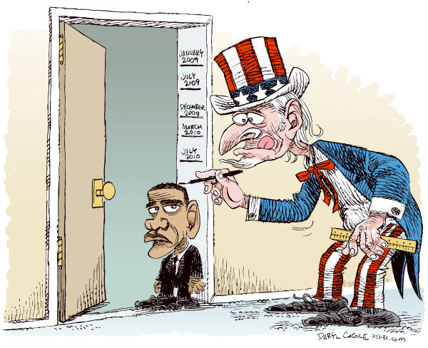
II. THE INSTITUTIONS OF GOVERNMENT.
CONTENTS: Foundations and structure of Congress; the president; the executive branch; the federal bureaucracy; the Judicial Branch; history of the Supreme Court; revisiting judicial review.
Week Seven-Ten: Congress.
- Patterson, Chapter Eleven
- Get to Know Congress: Letters to lawmakers
- Congress in Action!
  - Simulation: Congressional Lawmaking
- Congressional roundtable: spotlight on Reconstruction, Treaty of Versailles, Great Depression and Welfare Reform
- Exam Two

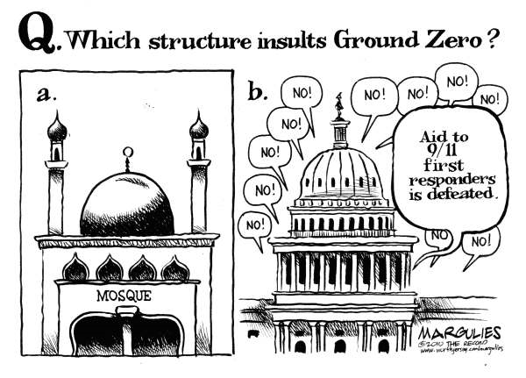
Week Ten-Eleven The Chief Executive.
- Patterson, Chapter Twelve
- How much power should the president have? Fineman, Chapter 9
- Discussion: The many roles or “hats” of the President
- Qualities of a President Activity: Evaluating Presidential Character
- Group Project: Presidential Nominating Committees

Practice FRQ
The President of the United States wears many “hats.” Describe the primary role of the president, how he/she gets elected and at least six “hats” along with their functions

RICHARD NIXON (1913-1994)
"With all the power that a President has, the most important thing to bear in mind is this: You must not give power to a man unless, above everything else, he has character. Character is the most important qualification the President of the United States can have."
(From TV ad for Barry Goldwater's presidential campaign in 1964.)
Source: http://www.pbs.org/newshour/character/quotes/
Practice DBQ
Read the selections from the War Powers Resolution and Julie Wolf’s article The Invasion of Grenada

The president has many functions in regards to the military and defense of our country. Describe the freedoms and limitations the president has in regards to military action and defense.

Week Twelve: The Federal Bureaucracy.
- Patterson, Chapter Thirteen
- Functions of the executive departments
- American Government Packet: Washington Post Article and Chart
  - Creating a Department of Homeland Security
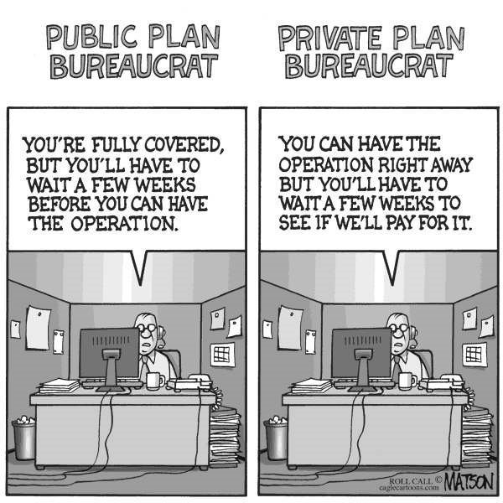
Week Thirteen-Fourteen The Judiciary.
- Patterson, Chapter Fourteen
- Fineman, Chapter 6
- Examining the Supreme Court
- American Government Packet: Marbury v. Madison, Dred Scott Case, Plessy v. Ferguson, Brown v. Board of Education, Korematsu, v. U.S., Johnson v. Texas, TLO v. New Jersey
- Review
- Unit 3 Exam
  - Multiple choice and DBQs
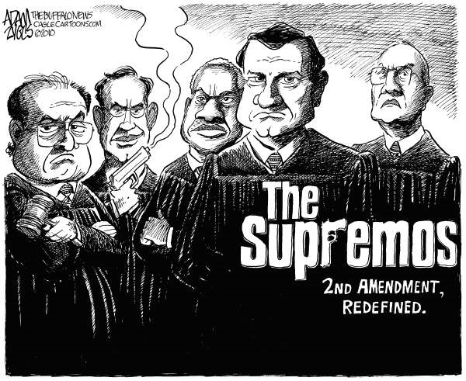
III. LIBERTIES AND RIGHTS
CONTENTS: Judicial interpretations of rights and liberties; freedom of speech, assembly, religion, expression and the accused; Civil Rights Movement; Women’s Rights; Immigrant Rights and Native American Rights (then and now).
Week Fifteen-Sixteen: Civil Liberties.
- Patterson, Chapter Four
- Fineman, Chapter 2-4
- What liberties are protected by the federal government?
- How have individuals fought for their rights in the U.S.?
- Spotlight on: West Virginia Board of Ed. V. Barnette, Rosenberg v. The Rector of University of Virginia
- You be the judge: Judge Roy Moore and the Ten Commandments Activity
- Rights of criminally Accused
  - Spotlight on: Miranda
- Flag Burning Texas V. Johnson
- The Death Penalty

Week Seventeen: Civil Rights.
- Patterson, Chapter Five
- Fineman, Chapter 1
- How has the government changed over time to better protect civil rights?
- How have movements forced the government to change civil rights policy?
- Civil Rights Movement
- American Government Packet: Abigail Adams reading and Lucy Stone reading
- Spotlight on: women’s suffrage
- Spotlight on: Gay Rights
- Plessy v. Ferguson, Brown v. Board of Ed.
- Native American rights? The AIM Movement
- Spotlight on today: Immigration
- Final Exam
Practice FRQ
Many textbooks suggest the Civil Rights Movement began in 1954, however, civil rights entered the political forefront since this country’s inception.

- Describe two Supreme Court cases and two congressional acts that affected civil rights prior to 1954.
- Describe how the country reacted to these cases and acts
- Describe two current legislative and judicial agendas that impact civil rights today

UNIT IV. THE FRAMEWORK OF GOVERNMENT.
CONTENTS: Philosophical bases of democratic government and political thought; the meaning of democracy; Political power; the framework of government: Revolution, Federalism and balancing power; Bill of Rights; Early Supreme Court and Judicial Review

Week Eighteen: American Political Culture
- Patterson, Chapter One
- Fineman, Chapter 5
- How was American political culture born and how has it influenced domestic and foreign decision making?
- What political power theory works best for the United States? How would it work elsewhere in the world?
- What is Politics?, handout
- Assessing Your Political values handout
- American Government Packet: Locke, Rousseau, Montesquieu
- Spotlight on: DeTocqueville v. Jefferson

Week Eighteen: From Colonialism to Constitutionalism
- Patterson, Chapter Two
- Why did the framers seek independence from England?
- Does limited, self government protect the rights of U.S. citizens?
- American Government Packet: Benjamin Banneker letter to Jefferson, Thomas Paine, Knox letter to Washington
- Polisims Two CD-ROM: What if You Were a Founding Father?
- Shays Rebellion: Why framers feared the people
- What ideas influenced the writing and adoption of the U.S. Constitution?

Week Nineteen-Twenty-One: Federalism
- Patterson, Chapter Three
- Why did the founders deem it necessary to include separation of powers?
- How did different theories of government lead to divisions between Federalists and Anti-Federalists? Were factions adequately addressed by the founders?
- Federalist Papers #10 and 51; Anti-Federalist Papers Cato #3 and Brutus #5
- Unit Exam

Practice DBQ
Read James Madison's “Vices of the Political System of the U. States” and the article from Atlantic Monthly. Using these sources and your textbook, respond to the following:

The Founding Fathers initially used the Articles of Confederation as our form of government before adopting the U.S. Constitution. What were the strengths and weaknesses of the Articles? Did the Constitution improve them? If so, how?

V. PUBLIC POLICY.
CONTENTS: What is public policy; how public and foreign policies are formed; public policy past and present: spotlight on New Deal; foreign policy: the president and Congress
Week Twenty-Two: Economic and Environmental Policy
  - Patterson, Chapter Fifteen
  - Fineman, Chapter 7
  - Fineman, Chapter 12
  - Episode: Journey to Planet Earth, “Future Conditional”

Week Twenty-Three: Welfare and Education
- Patterson, Chapter Sixteen
- How government affects poverty and education
- Primary Source: Thomas Jefferson, Notes on the State of Virginia
Practice FRQ
Describe three ways Congress has impacted poor people in the last 50 years. What role, if any, should government play in helping the poor?

Week Twenty-Four-Twenty-Five: Public and Foreign Policy.
- Patterson, chapter seventeen
- Fineman, Chapter 10
- Power Point: What the government does
- Spotlight on: The New Deal
- Public Policy Project: Immigration, Climate Change, Poverty and Health Care
- Examining documents: Foreign Policy in the Middle East
- Simulation: Foreign Policy debate: Securing our Borders

Week Twenty-Six: Review and AP Exam

VI. POLITICS AND YOU

CONTENTS: Our three branches today; the future of American Government; Breaking free from recession; American government inquiry projects and presentations; exam review

Week Twenty-Seven-Twenty-Eight: AP Exam Review

*Please note: schedule, assignments and readings may be changed or altered at the discretion of the instructor

* The remainder of the semester will be used for consumer economics or for civics action projects. You will receive consumer economics credit.

